The jQuery function name is actually $  
1.IN jquery:  
DOM manipulation is express by $

Basically

$(function ()

Means : *.addEventListener("DOMContentLoaded"...*

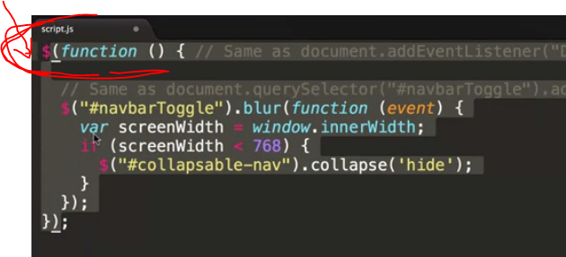

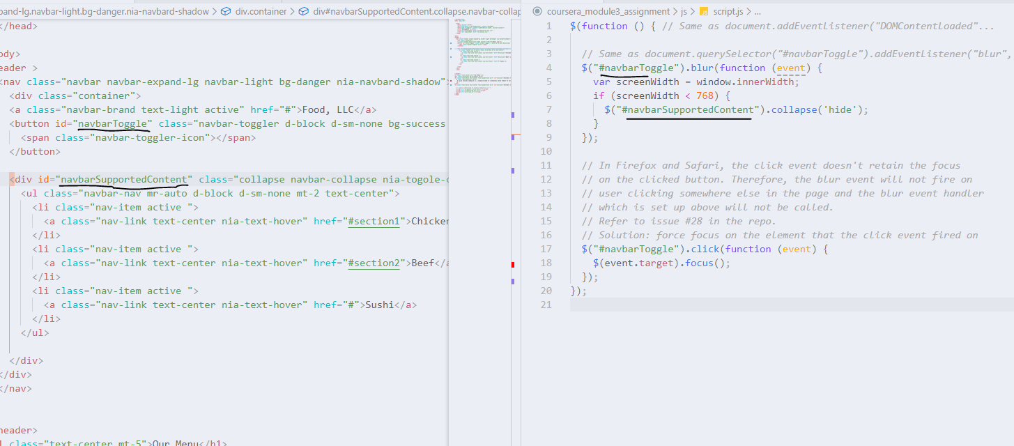

2. the jQuery dollar sign function also has another functionality, and

that is serves as a query selector

*Same as document.querySelector("#navbarToggle").addEventListener("blur",...*

 $("#navbarToggle")**.**blur(function (event)

3.to get the width of browser to have the break point :

window**.**innerWidth;